Atmospheric Pressure Belts and Wind Systems
- The gases that comprise air create pressure through their motion, size, and number. This pressure is exerted on all surfaces in contact with the air. The atmosphere exerts an average force of approximately 1 kg/cm2.
- At sea level, under the influence of gravity, air is compressed and is, therefore, denser near the Earth’s surface. It rapidly thins with increased altitude.
- A barometer is a scientific instrument that is used to measure air pressure in a certain environment. A more compact design that works without a metre-long tube of mercury is called an aneroid barometer.
- Isobars: a line on a map connecting points having the same atmospheric pressure at a given time or on average over a given period. An isobar is an imaginary line drawn through places having equal atmospheric pressure selected to sea level. The normal pressure at sea level is taken to be about 76 centimeters.
- The units used by meteorologists for this purpose is called millibars (mb).
- One millibar is equal to the force of 1 gram on a centimeter. It will be called the weight of column of mercury 75 cm height.

Pressure Belts of the Earth
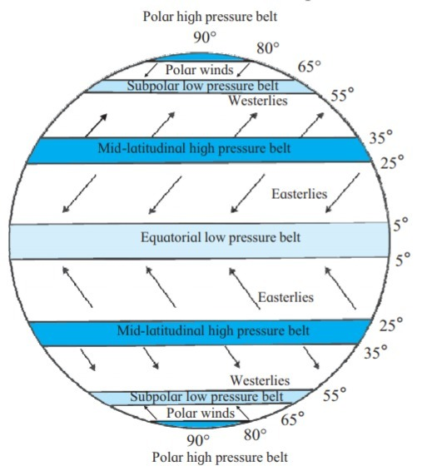
- The Equatorial Low-Pressure Belt
  - It is found near the equator. Lies between 10°N and 10°S latitudes.
  - The Earth receives maximum heat in this region with the result that the air is always hot and therefore becomes lighter.
  - The sea level pressure is low.
  - This belt is also called the Doldrums, because it is a region of calm, local thunderstorms occur frequently.
- The Sub-Tropical High-Pressure Belts
  - It is situated around the latitudes of 30°N in the Northern Hemisphere and 30°S in the Southern Hemisphere.
  - They are caused by the piling up of the air due to the differences in the speed of rotation of the Earth which affects the masses of air moving from the Equator and the poles.

- Subpolar low-pressure cells
  - It is located Ordinarily it should be a high pressure belt because of very cool air. But the air is rising here and the envelope of air is thin chiefly because rotation swings the bulk of the air towards the equator between 60° and 70° latitudes in the Southern and Northern hemisphere.
- Polar high-pressure cells
  - These occur near poles which have high pressure. It is located between 80 degree North and 90 degree South latitude in the Northern Hemisphere and Southern Hemisphere.

Winds System
- The horizontal movement of air is called wind. Wind is the horizontal movement of air caused by:
  - Heating by the Sun
  - Rotation of earth on its axis
- Note: The spacing of isobars expresses the rate and direction of pressure change and it is referred to as pressure gradient.
- Anemometer is used to measure wind speed.
- The wind belts girdling the planet are organised into three cells in each hemisphere: The Hadley cell, the Ferrel cell, and the Polar cell.
- In the middle latitudes, the circulation is that of sinking cold air that comes from the poles and the rising warm air that blows from the subtropical high.
- The Hadley cell or tropical cell, named after George Hadley, is a global-scale tropical atmospheric circulation that features air rising near the Equator, flowing pole ward at a height of 10 to 15 kilometers above the earth’s surface, descending in the subtropics, and then returning equator ward near the surface.
- At the surface, these winds are called westerlies and the cell is known as the Ferrel cell.
- At polar latitudes, the cold dense air subsides near the poles and blows towards middle latitudes as the polar easterlies. This cell is called the polar cell.

Types of Wind
Winds can be divided into three categories:
- Planetary Winds: Planetary winds or prevailing winds that blow throughout the year from one latitude to another in response to the latitudinal differences in air pressure.
- Periodic Winds: Periodic winds reverse their direction periodically with For example, monsoon winds.
- Local Winds: There are certain winds in different parts of the world which flow in comparatively small areas and have special These are called local winds and their nomenclature is usually derived from the regional language.

Planetary Winds
Planetary winds blow over vast areas of the globe. The two most prevalent planetary winds are Trade Winds and Westerly Winds.
- Trade Winds: The winds blowing from the subtropical high pressure belts to the equatorial low pressure belt. These winds are extremely steady and consistent throughout the
- The Westerlies: The winds blowing from the subtropical high pressure belts towards the sub-polar low-pressure belts are known as

Periodic Winds
Land and sea breeze come under this category.

Land and Sea Breezes
During the day, the greater heating of the land causes the air to ascend, causing a low pressure area over land and the cool heavy air from the sea moves in to take its place. This is Sea Breeze.
During the night, the land cools quickly so that it is colder than the sea. A low pressure area is caused over the sea and the cooler heavier air from the land begins to flow towards the sea. This is Land Breeze.

Local Winds
Local Winds | Region/Location
Simoon | Arabia
Pampero | Argentina (South America)
Zonda | Argentina (South America)
Santa Anas | California (USA)
Chinook | Canada & USA (Rockies Mountain Region)
Alisio | Caribbean
Karaburan | Central Asia
The Hawk | Chicago
Buran (also known as Purga) | East Asia
Khamsin | Egypt
Khamsin | Egypt
Helm | England
Mistral | France
Etesian | Greece
Norte | Mexico (Central America)
Papagayo | Mexico (Central America)
Norwester | New Zealand
Tramontana | North Italy
Loo | Northern India & Pakistan
Sirocco | Sahara Region (North Africa)
Bora | South & South Eastern Europe
Berg | South Africa
Levant | South France
Salano | South Spain
Bise | Switzerland
Foehn | Switzerland (Alps Region)
Gibli | Tunisia
Brickfielder | Victoria (Australia)
Harmattan (also known as Doctor Wind) | West Africa

Local winds in India
Elephanta: The Elephanta is a strong southerly or southeasterly wind which blows on the Malabar coast of India during the months of May and June and marks the onset of the southwest monsoon.
Kalbaishakhi or Norwesters: local rainfall and thunderstorm which occurs in India and Bangladesh. Kalbaishakhi or Norwesters originates in the Chhotanagpur Plateau, in and around the cities of Ranchi and Jamshedpur. Kalbaishakhi or Norwesters originates over Bihar and Jharkhand area moves eastwards and strikes West Bengal and Odisha. It occurs during April and May.
Kali Andhi or Black storm: the violent dust squalls that occur before monsoon in the northwestern parts of the Indo-Gangetic Plain region of the Indian Subcontinent.They are a common precursor to the arrival of the monsoon in the northern plains. It is quite common in southern Punjab, in the Cholistan and Thar deserts in Pakistan and Rajastan in India.
Loo: hot wind which blows over plains of India and Pakistan.The Loo mainly originates in the large desert regions of the northwestern Indian subcontinent: the Great Indian Desert, the Cholistan Desert and the desert areas of Southern Balochistan. Loo has extended its reach and has now gripped more parts of Rajasthan, Gujarat, Maharashtra, and even West Madhya Pradesh.
Mango showers: it is accompanied by thunderstorm bringing rainfall to Karnataka, Kerela and parts of Tamil Nadu during months of March and April.

Results of Wind
- Hurricanes- North Atlantic ocean, Gulf of Maxico
- Typhoons- Western North pacific ocean
- Cyclones- India
- Willy-Willy- Australia
- Tornadoes- N. America
- Jet Streams – Blows in upper Atmosphere
- Nor’easters and Blizzards/Kal-Baishakhi -
- Monsoon – Seasonal wind
- Baguio- China

