Marco Polo: Route Overview
Marco Polo was an Italian merchant born in 1254 C.E. who traveled with his father further east than most Europeans had ever gone. The goals of this journey were to spread Christianity to the ruling class of China and to establish trade relations with the new Yuan dynasty. Due to a unique political situation in East Asia, Europeans were able to enter China for possibly the first time. Upon entering, Marco Polo stayed for seventeen years working for the government as a diplomat.
Polo was from the Republic of Venice which was an Italian city that dominated Mediterranean trade in the 13th century. Marco Polo's travels began when he was seventeen and ended when he was forty-one years old. Polo's route took him through an overland journey across Central Asia in which he spent almost two decades working and traveling for the Yuan Dynasty, and finally led him through a set of sea voyages that took him all the way back to Venice.
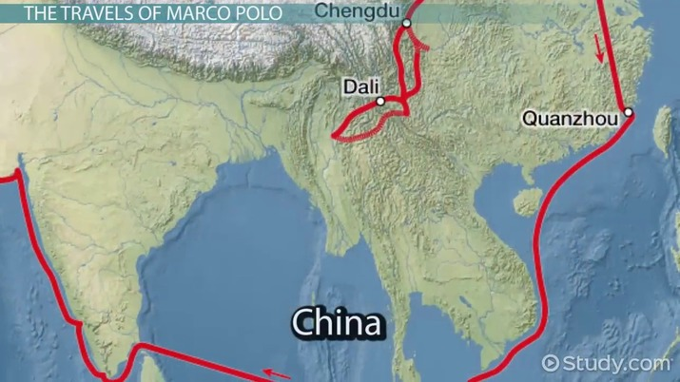
Save
Timeline
Autoplay
Speed Normal
- Video

- Quiz

- Course
16K views
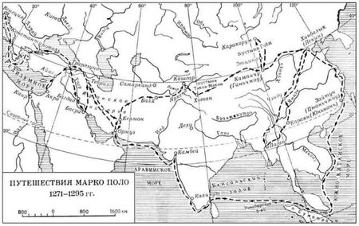
The route Marco Polo took exposed him to a wide variety of different cultures, technology, and people.

Marco Polo: Travels and Background
Marco Polo's travels would not have been possible one hundred years before or one hundred years after this extensive journey took place. This is because Chinese Dynasties were largely uninterested in Europe and most peoples outside their border. Europe was just coming out of the Middle Ages and did not have a single good to trade with China as China produced most goods it wanted, and traded with India, Southeast Asia, and the Middle East for the rest. Without any goods to trade, there was no reason to let Europeans into the country. However, during the 13th-century things were different.

The Expansion of the Mongolian Empire
During the early 1200s, Genghis Khan and the Mongolian people had managed to build the largest contiguous empire in history. This stretched from China all the way to Eastern Europe. By the time Genghis Khan's grandson Kublai Khan was ruling, the Mongolian Empire was much more open to foreign influence than traditional Chinese ruling dynasties. Kublai Khan based the empire in China as an attempt to gain greater control over the Chinese people and admitted many foreign merchants and travelers who sought to speak with the ruler of this vast empire.
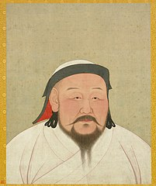
Kublai Khan tried to solidify Mongol rule in China

Italian Trade Networks
During the 13th century, wealthy cities controlled small regions of the Italian peninsula. From Genoa, to Pisa, to Venice, individual cities became incredibly wealthy from trade in the Mediterranean. Venice was the most powerful of these trade empires and was slowly taking control of port cities in the Eastern Mediterranean to profit off of the rich trade centers in the Middle East.

The Polo Family and Commerce
As part of the effort to expand Venetian trade further east, Marco Polo's father and uncle made their way east and sought to reach the capital of the vast Mongolian Empire, Shangdu. This empire was heavily influential in Europe so if the Venetians could establish a relationship with them, they could increase their trade monopoly in Italy and the Mediterranean.
Niccolo Polo left with his brother Maffeo Polo before Marco Polo was even born and these two brothers were gone for fifteen years. In that time they met Kublai Khan, traveled around China, and exposed the ruler to European ideas such as Christianity. Upon learning about this religion, Khan requested that the Pope send dozens of Christian intellectuals who would be able to convince him that Christianity was better than the Mongol religion.
Armed with a letter from Kublai Khan to the Pope, the Polo brothers returned to Venice and met Niccolo's 15 year old son Marco Polo for the first time

When Did Marco Polo Travel?
By the time the Polo brothers could give the Pope their letter from Kublai Khan, Marco Polo was seventeen years old. Upon reading the letter, the Pope agreed to send two Dominican Monks, instead of the requested dozens. Regardless, the Marco brother began their journey back to China in hopes of converting the ruling class and they decided to bring the young Marco Polo along. _When Marco Polo traveled he was one of the youngest people to ever venture so far in the pre-modern world.
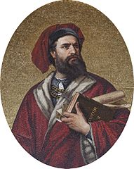
Marco Polo travelled over 15,000 miles
The journey lasted almost two decades and included many notable events:
1271: Marco Polo joins his father and uncle on their journey back to China. They go first to Acre, a city in the Holy Land, modern-day Israel.
1272: Marco Polo rides a camel to the Persian trading center of Hormuz.
1274: The Polos reach Shengdu, China, but the two monks turned back long before reaching the capital.
1275: Kublai Khan appoints Marco Polo as one of his diplomats.
1280s: Marco Polo travels to India, Burma, Indonesia, and all over Southeast Asia representing the Mongolian Empire.
1292: Marco Polo asks Khan for permission to go home and is tasked as his final mission to take Kublai Khan's daughter to Persia so she may marry into the royal family.
1295: Marco, Niccolo, and Maffeo Polo return to Venice and are reportedly unrecognizable to their family members.

Where Did Marco Polo Travel?
Marco Polo's travel route was not direct. The three Polos made their way to China by first going to the Middle East and then trekking through Central Asia. Once they arrived, their travels were not over because in order to establish a relationship with the Mongolian Empire, the Polos were going to have to prove themselves again. Niccolo and Maffeo Polo already had a relationship with Kublai Khan and without the monks that the Khan requested, it was going to be difficult to create a relationship between the Venetian Republic and Mongolian Empire.

The Middle East
The first place the Polos ventured on this journey was Acre in the Holy Land. This region was the center of the Crusades which were religious wars between Christians and Muslims which had been ongoing for over one hundred years. By the time the Polos arrived here in 1271, a Christian government still controlled this city but Muslim powers in the region were closing in.
In Acre, the Polos waited for a new Pope to be elected in order to bring along the Christian intellectuals Kublai Khan requested. They also wanted to provide Khan with a letter from the Pope to establish a relationship between the two influential leaders. Once a pope was elected, they began their journey further east.

Central Asia
Marco Polo went from Acre to Hormuz in Persia. Persia was a very wealthy region and Hormuz was one of the most opulent of Persian cities. As an island in the Persian Gulf, Hormuz acted as a chokepoint for trade and as the perfect port city. To a family of merchants, this city was incredibly interesting. However, after leaving this city they headed north and followed the Silk Road in Central Asia. This road connected western and eastern Asia and was largely populated by semi-nomadic people who were merchants themselves, moving goods from China to the Middle East.

East Asia
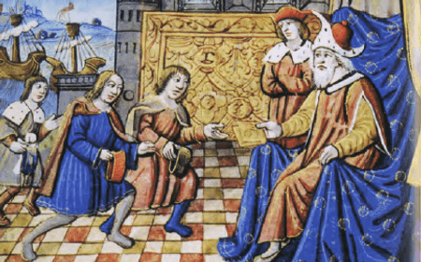
European depiction of Marco Polo meeting Kublai Khan

