Hydrologic Cycle
The water, or hydrologic, cycle describes the pilgrimage of water as water molecules make their way from the Earth’s surface to the atmosphere and back again, in some cases to below the surface. This gigantic system, powered by energy from the Sun, is a continuous exchange of moisture between the oceans, the atmosphere, and the land.

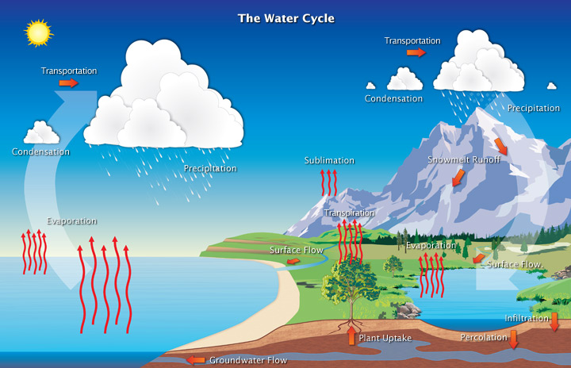
Diagram of the water cycle
Studies have revealed that evaporation—the process by which water changes from a liquid to a gas—from oceans, seas, and other bodies of water (lakes, rivers, streams) provides nearly 90% of the moisture in our atmosphere. Most of the remaining 10% found in the atmosphere is released by plants through transpiration. Plants take in water through their roots, then release it through small pores on the underside of their leaves. In addition, a very small portion of water vapor enters the atmosphere through sublimation, the process by which water changes directly from a solid (ice or snow) to a gas. The gradual shrinking of snow banks in cases when the temperature remains below freezing results from sublimation.
Together, evaporation, transpiration, and sublimation, plus volcanic emissions, account for almost all the water vapor in the atmosphere that isn’t inserted through human activities. While evaporation from the oceans is the primary vehicle for driving the surface-to-atmosphere portion of the hydrologic cycle, transpiration is also significant. For example, a cornfield 1 acre in size can transpire as much as 4,000 gallons of water every day.
After the water enters the lower atmosphere, rising air currents carry it upward, often high into the atmosphere, where the air is cooler. In the cool air, water vapor is more likely to condense from a gas to a liquid to form cloud droplets. Cloud droplets can grow and produce precipitation (including rain, snow, sleet, freezing rain, and hail), which is the primary mechanism for transporting water from the atmosphere back to the Earth’s surface.
When precipitation falls over the land surface, it follows various routes in its subsequent paths. Some of it evaporates, returning to the atmosphere; some seeps into the ground as soil moisture or groundwater; and some runs off into rivers and streams. Almost all of the water eventually flows into the oceans or other bodies of water, where the cycle continues. At different stages of the cycle, some of the water is intercepted by humans or other life forms for drinking, washing, irrigating, and a large variety of other uses.

