brhectorsgeoworld
This blog is created to help my students to understand geography better.
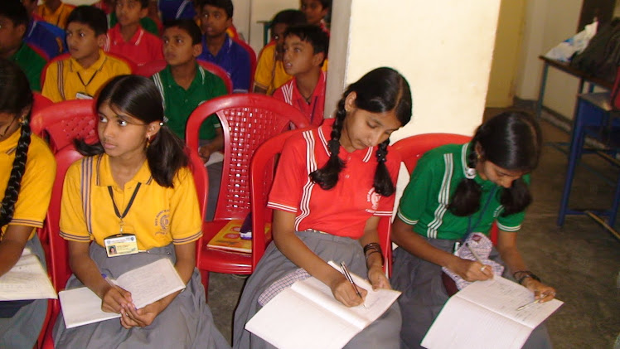

Thursday, June 18, 2009

C1A- SAARC NATIONS- LOCATION AND PHYSICAL FEATURES OF INDIA
Physical features of South Asia(focus on India, Pakistan, Bangladesh and Nepal)
•South Asia is a land of physical diversity.
•Himalayas – youngest mountains
•Region of South Asia has a distinct geographic entity separated from rest of Asia by Himalayas, Kirthars, Sulaiman , Hindukush ranges and Purvanchal ranges.
•Countries – India
•Pakistan
•Bangaladesh
•Nepal
•Bhutan
•Sri Lanka
•Maldives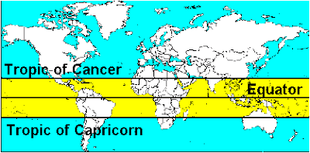
•South Asia is a physically well defined realm with the
Himalayan mountains to the north, the Karakoam and Hindu Kush mountains to the northwest deserts to the west, and dense forest and hills along the Burmese (Myanmar) border to the east. South Asia spans a large area and contains great physical variety.
•Much of the subcontinent is tropical ; only at higher elevations in the north and northwest is frost common. The main climatic variable is the amount of precipitation and its seasonally . 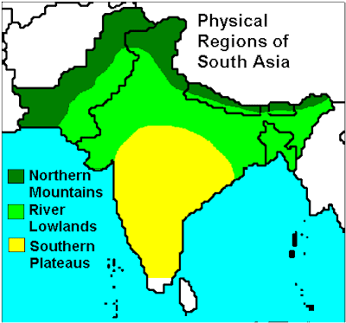
•The landforms of the subcontinent are divided into three major physical regions:
•The Northern Mountains
•The River Lowlands
•Southern Plateaus
INTRODUCTION

Himalayan Mountains in the north & Indian Ocean in the south have been separated to form a big landmass.
•Located in southern part of continent of Asia.
•Called sub-continent – for varied relief features, climate, natural vegetation & diversities among people
•Unity in diversity – famous for art, literature, dance, agriculture, industries.
•Enriched culture.
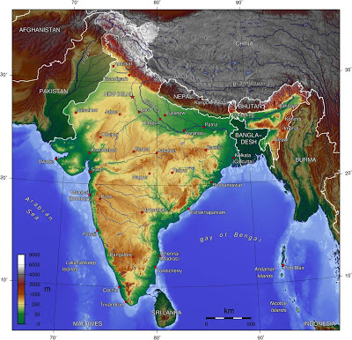
India’s neighbours
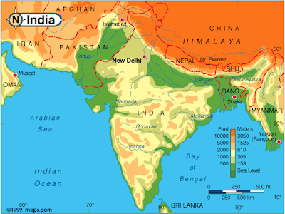
China, Nepal, Bhutan in the North
•Myanmar & Bangladesh in the east
•Pakistan in the north-west, Sri Lanka
INDIA
•Plateau- triangular in shape.
•Occupies – 2.4% of total area of world.
•7th largest country
•Located fully in northern & eastern hemisphere
•8 N & 37 N latitude – 68 E & 97 E longitude
•Total area- 32,87,263 sq kms
•Extends over 2,933 km from east to west & 3,214 from north to south
•28 states – 7 centrally administered Territories.
•New states – Chhattisgharh, Jharkhand, Uttaranchal in 2000
•Islands – Andaman and Nicobar Islands , Lakshadveep
•Coastline – 7,516.5 kms
•Land border –length – 15,200 kms with neighbouring countries
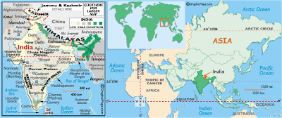
•The Tropic of Cancer (23 ½ N latitude) passes through the middle of the country & divides India almost two halves.
•82 ½ East longitude passes near Allahabad is central meridian of India.(it means that when it is noon on the longitude of 821/2 degree E , the time taken for the whole of India is taken as noon, although at places to the east of standard meridian it is already past noon and at places to the west of the standard Meridian it is not yet noon.
•Indian standard Time – based on this longitude

INDIA
•Sovereign Democratic Republic.
•28 states, 6 union territories for effective administration
•Delhi – capital
•Rajasthan – largest state – area of 3,42,239 sq. km
•Goa – smallest state – 3,702 sq. km
Physical divisions
-Variety of landforms.
-Landforms were formed in different stages of earth’s geological history
-Major physical divisions
1.The Northern mountains
2.The North Indian Plain.
3.The Peninsular Plateau
4.The coastal regions and Islands
5.Western and Eastern Ghats
6.The Thar Desert (Great Indian Desert)
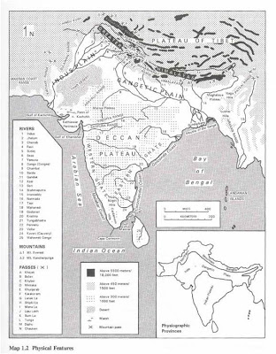•
Himalayan mountains form northern mountain
•Highest mountain ranges in he world
•Have highest mountain peaks, deep valleys, glaciers etc
•Mountain ranges start from Pamir Knot in the west & extend upto Nagaland in the east.
•Extend over 2,500km.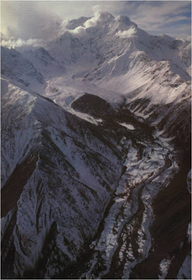
•Spread of land space along the mountains is about 5.0 lakh square kms. •Himalayas, the highest mountain system in the world, is also one of the world's youngest mountain ranges.
• It extends practically uninterrupted for a distance of some 2500 km and covers an area of about 500,000 sq km.
•These fold mountains comprises mainly of three main almost parallel ranges with intervening valleys.
•Include Himalayas, Trans-Himalayan Ranges and Eastern Hills or Purvanchal.
• It contains the world's highest mountain peak, Everest and some ten peaks rising above 7,500 m.
• It appears to have risen as a result of a collision between the drifting Indian (peninsular) plate and the Tibetan plate of South Asia about 50 million years ago.
•The Himalayas reached their present heights much later.
HIMALAYAS FROM SPACE

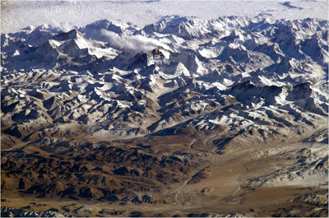
Born out of the Tethys Sea which lied between the Gondwanaland in the South & Angarland in the north.
•Have been formed during different stages of continental drift of the Gondwana landmass.
•Tethys sea was receiving sediments from rivers like Indus, Sutlej and Tsangpo.
•100 million years ago Gondwanaland of the peninsular India drifted towards the Tethys Sea, thus pushing up the sediments to the north.
•Due to successive movements of earth, the Greater, then the Lesser and finally the Outer Himalayas were formed.
•There are 3 parallel ranges in the Himalayas.
1.The Greater Himalayas or Himadri
2.The Lesser Himalayas or Himachal
3.The Outer Himalayas or Siwaliks
1. Greater Himalayas or Himadri
•Highest range of the Himalayans mountains.
•Average height of this range is 6000mts.
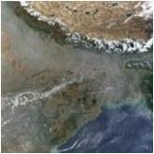
•Some peaks are more than 8000 mts.
•Range extends from Nanga Parbat in the west to Namche Barwa in the east.
•Highest peak of Himalayan mountains are in this range.
•Nanga Parbat peak (8,126 m), Namcha Barwa peak (7,756 m)
MOUNT EVEREST
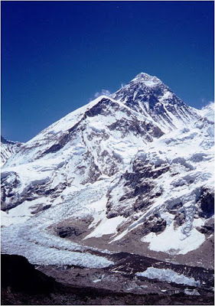
•Himalayan Range, Mount Everest, Nepal. 8848m
•Its between Tibet and Nepal.
•Highest peak in the world
•GPS was used in 1999 to verify its height.
•First scaled in 1958.
•600 climbers from 20 countries have reached the peak.
•100 have died.
•China is planning to build highway to Mt. Everest. Latest report
MOUNT GODWIN AUSTIN (K2)
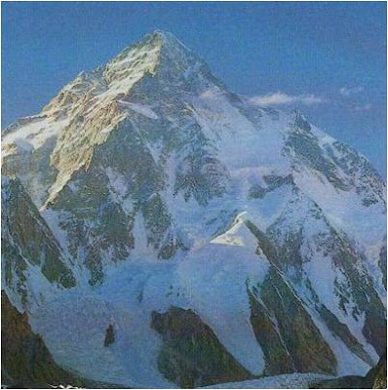•Mount Godwin Austin or K2 is the highest mountain peak in India.
•Second highest in the world.
•Height – 8,611 mts- in the Karakoram range

KANCHENJUNGA 8,598 MTS
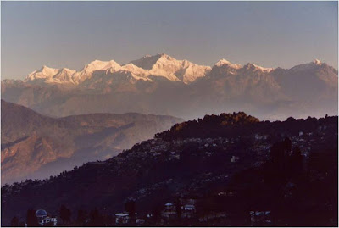
•In Sikkim-highest Himalayan peak in India.
Annapurna – Himalaya, Nepal

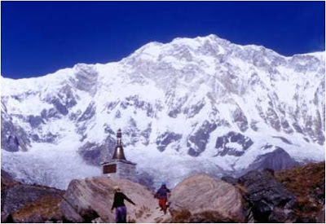
•8091meters high, 10th highest in world.
Name means ‘The Provider’
Giant glaciers empty into the Kali Gandaki river.
OTHER PEAKS ARE: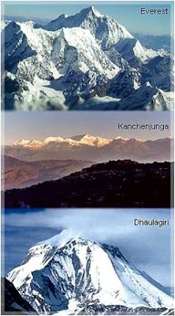
•Dhaulagiri
•Makalu
•Nanga Parbat
•Nanda Devi
Gowri Shankar
GLACIERS
•Mountain range has many glaciers.
•Most important is Gangotri glacier which is the source of the river Ganges.
•The passes in this mountain range are at a height of above 4,570 mts.
•Important passes are Shipki-la which connects Gartok in Tibet with Simla in HImachal Pradesh across Sutlej river & Jelep-la which connects Llasa, the capital of Tibet with Kalimpong in West Bengal.
•They provide good transport facility & also attract tourists.

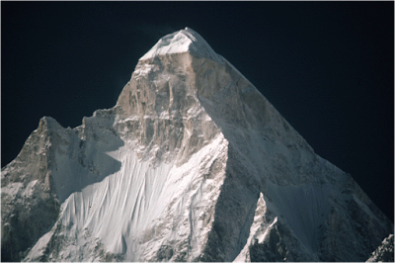
GANGOTRI GLACIER

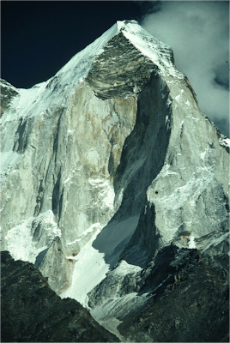GANGOT

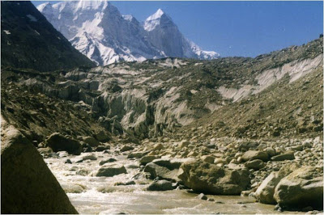ORIGIN OF GANGA
LESSER HIMALAYAS OR HIMACHAL

•Is about 3,600 mts to 4,500 mts high.
•Has parallel ranges & some of them are covered with snow
•Forests in the northern part of these ranges
•Pir Panjal, Dhauladhar, Mahabharat, Mussoorie ranges are important ranges.
•Contain mountain valleys & hill stations
•Kashmir valley, Kangra Valley, Kulu valley, Lahul Valley are important valleys
•Noted for scenic beauty & attract many tourists
•Shimla, Ranikhet, Mussoorie, Nainital, Darjeeling-important hill stations of these ranges .
OUTER HIMALAYAS OR SIWALIKS

•These are foothills of the Himalayas.
•These ranges are formed by the deposition of materials brought down by the rivers, which rise in the Himalayas and flow through these ranges.
•Average height – about 1300 mts.
•In these ranges there are many narrow plains, called doons, eg. Dehradoon.
Importance of Himalayan mountains -
•Checks the chilly cold winds that blow from central Asian and Siberian regions
•Northern river plain region is comparatively warm.
•Stop the monsoon winds and cause rainfall & to its fertility.
•They are source of many rivers.
•They are source of minerals.
•Rivers that flow on their slopes are helpful for irrigation & generation of hydro-electricity.
•They attract tourists.
•Their valleys are noted for the cultivation of fruits like apples & crops like tea & saffron
•Many medical plants & herbs grow in these mountains.

NORTH INDIAN PLAIN
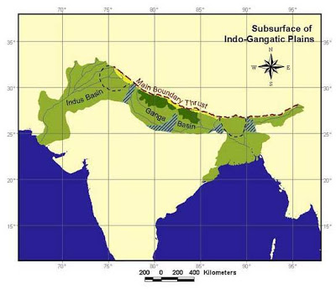•Is also known as Gangetic plain
•Total area – 6,52,000 sq. km.
•Is situated between the Himalayan Mountains in the north & the Peninsular plateau in the south
•Is formed by alluvium brought down by the rivers
•Sindhu,Ganga, Brahamaputra rivers and its tributaries originate from Himalayas 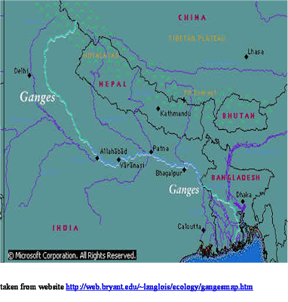
•Flow in the northern plain.
•Full of water in rainy season
•In summer- snow melts
•Useful for agriculture – fertile
•Alluvial soil washed down adds to fertility of the plains
•Wheat, sugarcane, rice are grown in plenty
•Since land is almost flat, it is very easy to construct irrigation canals & have inland navigation
•Has excellent roads and railways, which helped in establishment of many industries.
•40% of the total population of India lives here.
•Therefore it is called “The heart of India.”
PENINSULAR PLATEAU

•It is the largest of India’s physical divisions.
•Narmada rift valley divides the peninsular plateau into 2 parts – Malwa plateau & Deccan Plateau
•Malwa plateau is bounded by Aravalli hills in the north west & Vindhya mountains in the south
•Central India – valleys of Narmada & Tapti rivers
•Vindhya and Satpura ranges separate Deccan Plateau from North India

GEOLOGICAL HISTORY OF DECCAN PLATEAU

•The vast volcanic basalt beds of the Deccan were laid down in the massiveDeccan Traps eruption, which occurred at the end of the Cretaceous period, 65 million years ago. Some paleontologists speculate that this eruption may have accelerated the extinction of the dinosaurs. Layer after layer was formed by the volcanic activity that lasted many thousands of years, and when the volcanoes became extinct, they left a region of highlands with typically vast stretches of flat areas on top like a table. Hence it is also known as Table Top. The volcanic hotspot that produced the deccan traps is hypothesized to lie under the present day island of Réunion in the Indian Ocean.
Typically the Deccan Plateau is made up of basalt extending upto Bhor Ghatnear Karjat. This is an extrusive igneous rock. Also in certain sections of the region, we can find granite, which is an intrusive igneous rock. The difference between these two rock types are: basalt rock forms on eruption of lava, that is, on the surface (either out of a volcano, or through massive fissures -- as in the Deccan basalts -- in the ground), while granite forms deep within the Earth. Granite is a felsic rock, meaning it is rich inpotassium feldspar and quartz. This composition is continental in origin (meaning it is the primary composition of the continental crust). Since it cooled underground, it has large visible crystals. Basalt, on the other hand, is mafic in composition -- meaning it is rich in pyroxene and, in some cases,olivine, both of which are Mg-Fe rich minerals. Basalt is similar in composition to mantle rocks, indicating that it came from the mantle and did not mix with continental rocks. Basalt forms in areas that are spreading, whereas granite forms in areas that are colliding. Since both rocks are found in the Deccan Plateau, it indicates two different environments of formation
•The Deccan is rich in minerals. Primary mineral ores found in this region are mica and iron ore in the Chhota Nagpur region, and diamonds, gold and other metals in the Golconda region.

Deccan Plateau – satelite photograph
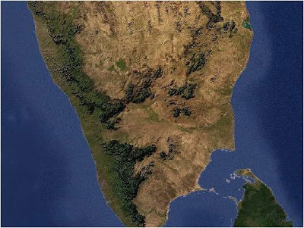•oldest land masses of the world & is formed of hard rocks
•Total area of both plateaus – 7,05,000 sq. km.
•Triangular shape
•Malwa plateau slopes towards Gangetic Plain.
•Highest peak on the Aravallis is Mt. Guru Shikhar.
•Mt. Abu – famous hill station on Aravallis 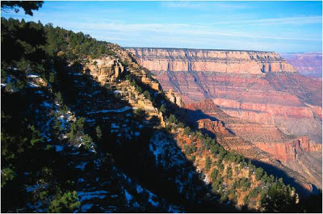
•Deccan plateau is surrounded by Satpura hills, Mahadeo hills, Maikala range, Amarkanak hills, Rajmahal hills in the north and Western Ghats in the west and the Eastern Ghats in the east.
•Eastern & Western Ghats – serve borders to plateau.
•These ghats meet each other at Udagamandalam (Ooti) (Nilgiri hills)
•Tableland slopes eastwards
•Height is great in the west
•So rivers originating on Western Ghats flow eastwards.
•Include Mahanadi, Godavari, Krishna, Cauvery and their tributaries.
•Smaller east flowing rivers like the Pennar, Palar and the Tamraparni.
•Small west-flowing rivers originating on Western Ghats or Sahyadri and watering the West Coast like Mandovi, Kali, Netravati, Pamba and the Manimala in Kerala.
EASTERN GHATS
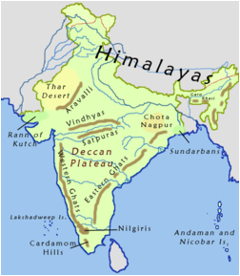
•Eastern Ghats, bordering the East Coast of India, is cut up by the powerful rivers into discontinuous blocks of mountains.
•In its northern parts between the Godavari and Mahanadi rivers it rises to above 1000 metres .
DIFFERENCE BETWEEN WESTERN GHATS AND EASTERN GHATS:
WESTERN GHATS are higher & continuous 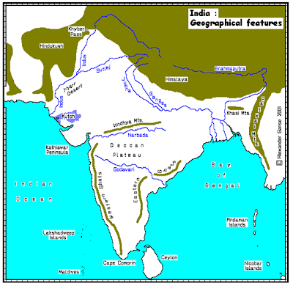
EASTERN GHATS are not very high and continuous. They are broken
Western Ghats are closer to the sea whereas Eastern Ghats are not closer to the sea.There are wider plains in between Eastern ghats and the sea.
IMPORTANCE OF PENINSULAR PLATEAU
•Has economic importance because :
•Of its rich mineral resources
•Many rivers have waterfalls – help in generation of hydro-electric power.
•Tourist attraction
•Suitable for cotton cultivation
•Dense forests are home of many wild animals
COASTAL PLAINS AND ISLANDS
India – 6,100 km length of coastline.
•Extends from Kachchh in Gujarat in the west to the Gangetic delta in the east.
•Coast of India is divided into Western Coastal plain and Eastern Coastal plain.
•Western coastal plain lies between Western Ghats and the Arabian sea & extends from Gulf of Kachchh in the north to Cape Comorin (Kanyakumari) in the south to the length of about 1,500 km.
•It is divided into Malabar Coast, Karnataka (Canara) coast, Konkan coast, Gujarat coast, Kachchh & Kathiawad peninsulas.
•Coast is straight and affected by the South-West Monsoon winds.
•So there are only few good harbours.
•Important Ports -Kandla, Mumbai, Nhava-Sheva, Marmagoa. Karwar, Mangalore, Kochi
•Eastern coast extends from Kanyakumari to the Gangetic delta & between Eastern Ghats and Bay of Bengal.
•It constists of the deltas of rivers Mahanadhi, Godavari, Krishna, Kaveri.
•It is broad & flat land.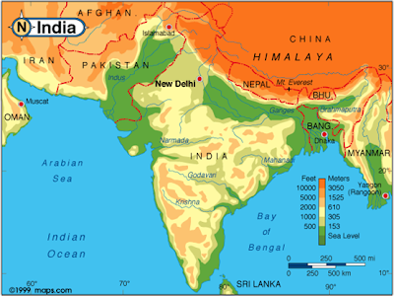
•There are some salt water lakes or lagoons
•Chilka lake of Orissa, Pulicat Lake of Tamilnadu
•Ports in Western Coast – Cambay, Kandla, Surat, Mumbai, Goa, Karwar, Mangalore, Kozhikode (Calicut), Cochin, Trivandrum, and ancient port of Muziris (Kranganore)
•Eastern coast ports – Tamluk , Kolkotta, Paradeep, Vishakapattanam, Chennai, Pondicherry & Tuticorin.
IMPORANCE OF COASTAL PLAINS
•Good for agriculture, trade, industrial centres, fishing, & salt making.
•Provide important hinterlands for the ports.
•Play an important role in the economic development of India.
ISLANDS OF INDIA

ANDAMAN AND NICOBAR ISLANDS
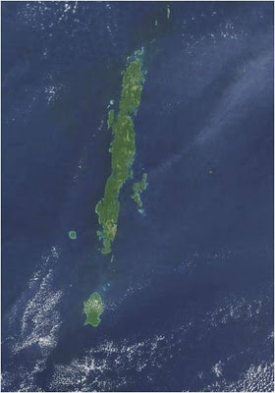

•247 islands in India.
•204 islands in the Bay of Bengal.
•43 in Arabian Sea
•Few coral islands in the Gulf of Mannar
•Andaman & Nicobar islands in Bay of Bengal consist of hard volcanic rocks
•Middle Andaman & Nicobar Islands – largest islands of India.
•Southern – most point is in Great Nicobar Island.
•Called Indira Point

LAKSHADWEEP
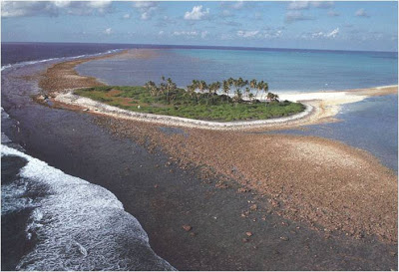
•Lakshadweep islands are in Arabian Sea.
They are formed by corals and are surrounded by fringing reefs. They have total area of 32 square kilometres.

RIVERS & LAKES OF INDIA
•Varied relief – so there are several river systems in India.
•The main rivers of the Himalayan group are the Indus, the Ganga and the Brahmaputra.
•These rivers are both snow-fed and rain-fed and have therefore continuous flow throughout the year.
•Himalayan rivers discharge about 70% of their inflow into the sea.
•This includes about 5% from central Indian rivers. They join the Ganga and drain into the Bay of Bengal.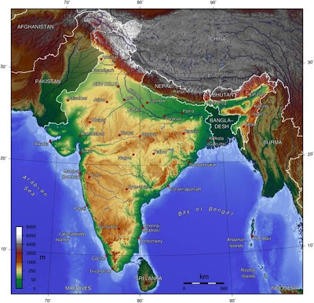
•Rivers play important role in the economic development of India.
•Generate hydro-electricity
•Help in irrigation
•Help in inland navigation
•River system can be divided into two groups.
•1. North Indian rivers
•2. South Indian rivers
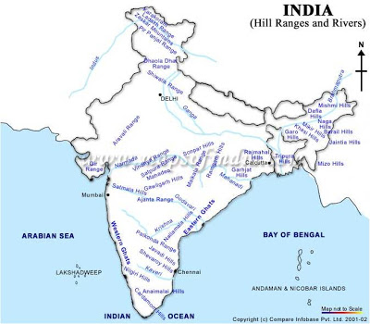
NORTH INDIAN RIVERS

•Mostly rise in the Himalayan mountains
•Are snowfed & rainfed
•Perennial in character
•There are 3 river systems in North India.
•Indus, Ganges, Brahmaputra

RIVER GANGES AND ITS TRIBUTARIES

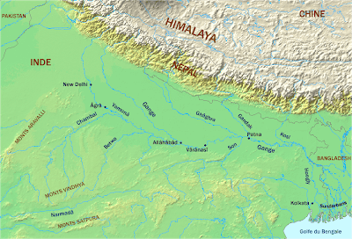The Ganga, famous alike in legend and history, is considered the most sacred river by the Hindus. It covers, what is called the heartland of India, which was the main centre of the ancient Aryan culture.
It rises near the glacier, Gangotri in the Himalayas and flows through Uttar Pradesh, Bihar and Bengal to fall into the Bay of Bengal. Gangaand its tributaries Jamuna, Gornti, Garga, Sarda, Gandak, Chambal, Son and Kosi, spread out like a fan in the plain of India thus forming the largest river basin in India, with an area, one quarter of the total area of India.

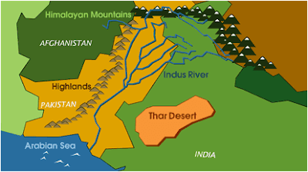•
The Indus, which the Aryans called the Sindhu, has lent its name to India.
•Its valleys on both sides have been the seat of a civilization.
•The Brahmaputra rising in western Tibet, flows for some 1300 km through the Himalayas, then turns south-west and then south, joining the easternmost branch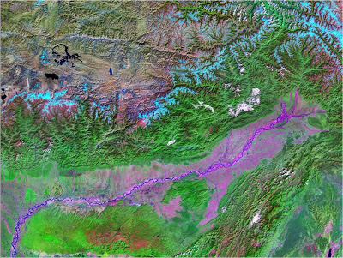 of the Ganga the Padma and empties together with Ganga into the Bay of Bengal.
•The rivers of Deccan denuding their beds for long geological ages have developed flat valleys with low gradients. The major Deccan rivers are the Godavari, the Krishna, the Cauvery, the Pennar, the Mahanadi, the Damodar, the Sharavati, the Netravati, the Bharatapuzha, the Periyar, the Pamba, the Narmada and the Tapti.
•These rivers are entirely rain-fed with the result that many of them shrink into rivulets during the hot season. The Deccan rivers contribute about 30% of the total outflow in India. Of this, the rivers that flow from west to east account for 20% and those from east to west about 10%

SOUTH INDIAN RIVERS

•Rain fed
•Flow only during the rainy season.
•Dry in summer
•Seasonal rivers and dams are constructed across them to store water.
•Since they flow on the slopes of the ghats, they have many waterfalls.
•Helpful in generation of hydro-electricity .

LAKES

•Few natural lakes in India
•Salt water lakes – Chilka & Pulicat
•In Kerala – few backwaters
•Dal lake in Kashmir – fresh water lake
•Wulur lake – fresh water
•Nal lake – fresh water lake near Ahmedabad- well known bird sanctuaryMagada masur lake near Dharwad, Sambar lake in Rajasthan and Kolleru lake in Andhra Pradesh – all important fresh water lakes
REVISION
Q.1: On which coast of India, the Malabar Coast lies?
Ans: Malabar Coast lies on the western coast of India.
Q.2: Which side of the Western Ghats has steep slope?
Ans: Southern side.
Q.3: Describe how Himalayas were formed?
Ans: The relief features of India were not the same as it were millions of years ago. They have undergone great changes during this long passage of time. Geologists have reasons to believe that where now the Himalayas stand, once there was a vast sea called Tethys. All these changes were brought by the internal movements of the earth and also external forces operating on the surface of the earth.
The heat of the earth produces many currents in the molten rocks inside the earth which, when rise above, tear the crust apart dividing it into large fragments called lithospheric or Tectonic Plates. These plates are floating over mantle of the earth. These plates in some places move away from each other while at other places they come close to each other and collide or they may horizontally move past over the other. The movements of these tectonic plates have changed the relief of the earth and that of India again and again during the past millions of years. The formation of Himalayas is also the result of the movements of these tectonic plates. It has been established by the geologists that one of such plates known as Indo-Australian Plate, separated from the super-continent Gondwanaland and drifted slowly towards north. It collided with the much larger Eurasian Plate, about fifty million years ago. The northern age of the Indo-Australian plate was pushed below the Eurasian plate. As a result of the collision of these two plates, the sedimentary rocks of enclosed ocean were folded to form the so-called Himalayas and other mountain systems of Central Asia.
Q.4: Write a short note on the Island groups of India.
Ans: In addition to the mainland India has a set of two islands - (1) the Andaman and Nicobar Islands, (2) the Lakshadweep of Islands.
Andaman Nicobar Islands: These islands lie in the Bay of Bengal. They are 233 in number. The northern cluster of islands are known as the Andaman Islands which are 214 in all while the southern cluster of islands are known as the Nicobar Islands which are 19 in number. Many of these islands are too small and uninhabited. They are located on the submerged hilly range. A few of these islands are of volcanic origin. India’s only active volcano is found in Barren Island in the Andaman and Nicobar Islands. These islands form the Union Territory of the Andaman and Nicobar Islands with Port Blair as its capital.
Lakshadweep Islands: These group of islands lie in the Arabian Sea about 300 km away from the Kerala Coast. They are horse-shoe shaped coral islands. These are 27 in number and about 17 of them are uninhabited. Thus they are smaller in size and less in number than the Andaman and Nicobar Islands. These islands form the Union Territory of the Lakshadweep with Kavaratti as its capital.
These island groups are of great strategic significance for India. Also they have a great diversity of flora and fauna. These islands experience equatorial climate since they lie close to the equator and have thick forest cover.
Q.5: Give any four characteristics of Ganga-Brahmaputra Delta.
Ans: Normally Delta is a triangular shaped land which is formed by the deposition of sediments at the mouth of a river. Some of the characteristics of the Ganga-Brahmaputra delta are as follows -
=> It is the largest delta in the world.
=> It is not only well-watered but also, highly fertile land-form.
=> The Brahmaputra after joining the Ganga becomes sluggish. Due to the gentle slope, islands of mud and silt develop in its channel and in order to circumvent these obstructions it splits into a number of channels. This process is going on continuously and as a result of which it has become the fastest growing delta in the world.
=> The lowest part of the delta has become marshy owing to the free mingling of river and sea waters by the high and low tides.
Q.1: Define:
a) Subcontinent
b) Indian Standard Time
Ans:
a) Subcontinent - A big geographical unit which stands out distinctly from the rest of the continent e.g., Indian Subcontinent
b) Indian Standard Time - The local time along the Standard Meridian (82degree 30’E) which serves as the Standard Time for the whole of India. It is 5 hrs. 30 minutes ahead of Greenwich Time.
Q.2: Why do we need a standard meridian for India? Explain. OR
The sun rises two hours earlier in Arunachal Pradesh as compared to Gujarat in the west but the watches show the same time. How does this happen?
Ans: From the longitudinal extent of India it is observed that the longitudinal expanse is about 30degree from west to east. This means that there would be a time-lag of two hours approximately from Gujarat to Arunachal Pradesh. To avoid such differences in local time, Indian standard time has been fixed to give the whole country a uniform time. The local time of the Standard Meridian of 82degree30’E is observed as the Standard Time by the whole country. Because of this reason we find that the sun rises two hours earlier in Arunachal Pradesh as compared to Gujarat in the west but the watches show the same time.
Q.3: Account for the two hours time difference between the two eastern and western extremities of India. Or,
When the sun has already risen in Arunachal Pradesh, it is still dark in Gujarat, why?
Ans: India is situated between 68degree 7’ to 97degree25’E Longitude which makes the longitudinal extent of India about 30degree. 1degree difference in longitude is equivalent to 4 minutes hence, 30degree = 120 minutes (1degree = 4 minutes, 30degree = 30 x 4 = 120 minutes or 2 hrs).
It means that the sun rises about 2 hrs earlier in the easternmost part of India i.e. Arunachal Pradesh than in the westernmost part i.e. Gujarat or Rajasthan. That is why when the sun has already risen in Arunachal Pradesh it is still dark in Gujarat.
Q.4: Reason out why the difference between the duration of day and night is hardly felt at Kanyakumari but it is not so in Kashmir.
Ans: Kanyakumari, which lies in the south, is nearer to the Equator than Kashmir which lies in the northernmost part of India. Days and nights are almost of equal duration on the equator but as we go away from it the difference between the day and night goes on increasing.
As Kanyakumari is much nearer to the equator than Kashmir so, the difference between the duration of day and night is hardly felt at Kanyakumari but it is not so in Kashmir.
Q.5: Which is the southern-most point of the Indian Union?
Ans: It is the Indira Point of the Andaman and Nicobar group of islands which is the southern-most point of the Indian Union.
Q.6: Give reasons: Why India is often referred to as a subcontinent?
Ans: India is often called as a subcontinent because of the following reasons -
a) India is a vast country with an area of 3287263 square km. It is the seventh largest country of the world.
b) India forms a major part of Asia which stands out distinctly from the rest of the Asian continent by natural features such as mountains, oceans and rivers. It has its own separate climatic characteristics and a distinct cultural identity as well as a strategically important location.
Q.7: Why 82degree 30’E has been selected as the Standard Meridian of India?
Ans: India lies to the east of the Prime Meridian between 68O7’ to 97O25’E Longitude which makes a vast longitudinal extent of India about 30O. To have one uniform time in the country, India has accepted 82O30’E as the Standard Meridian of India. The local time at this Meridian has been accepted as the Indian Standard Time (IST) throughout the country. It has helped to avoid a lot of confusion which would have been there by following different local times or in absence of a uniform time.
Q.8: Answer the following questions briefly:
(i) What are tectonic plates?
(ii) Which continents of today were parts of the Gondwana land?
(iii) What is bhabar?
(iv) Name the three major divisions of the Himalayas from north to south.
(v) Which plateau lies between the Aravali and the Vindhyan ranges?
(vi) Name the island group of India having coral origin.
Ans:
(i) Due to internal heat of the earth, the currents of the semi-molten rocks begin to move towards the crust and tear it apart dividing it into large fragments called lithospheric or tectonic plates. There are seven such major plates namely, South America, North America, Pacific, Indo–Australian, Eurasian, African and Antarctic.
(ii) Gondwana land is the name given to the hypothetical Southern hemisphere ‘super-continent’ consisting of South America, part of Africa (south Africa including Madagascar), part of Asia (India, Arabia, Malaya), Australia and Antarctica, prior to its break-up under the forces causing continental-drift.
(iii) The ‘Bhabar’ is that narrow belt of the plain which is covered with pebbles and lies along the foothills of the Shiwaliks from the Indus to the Teesta. This belt is laid down by numerous streams descending down the hills.
(iv) The Himalayas represent the loftiest and one of the most rugged mountain barriers of the world. The three major divisions of the Himalayas from north to south are –
(a) The northernmost range which is known as the great Himalayas or Inner Himalayas or the Himadri.
(b) The range lying to the south of the Himadri which is known as Himachal or the lesser Himalaya.
(c) The outermost range of the Himalayas which is known as the Shiwaliks. Theses are the foothill ranges and represent the southernmost division of the Himalayas.
(v) Malwa plateau.
(vi) Lakshdweep.
Q.9: Distinguish between
(i) Converging and diverging tectonic plates.
(ii) Bhangar and Khadar
(iii) Western Ghats and Eastern Ghats.
Ans:
(i) The internal heat of the earth makes the molten rocks to rush towards the surface of the earth and drive the crust into large fragments known as “Tectonic Plates”. These plates are drifting oven the mantle of the earth. As a result when the two or more plates are pushed towards each other they are called ‘Converging Plates’. On the other hand if they are moving away from each other, they are called ‘Diverging Plates’.
(ii) According to the age of the soils of the Northern Plain they have been differentiated by two names: (a) Bhangar and (b) Khadar. The difference between these two are mentioned below –
(a) Bhangar - These are the older alluvium or old soil and form the largest part of the Northern Plains. They lie above the flood plains of the rivers and present a terrace like structure. It often contains Kankar nodules made of calcareous deposits.
(b) Khadar - The newer and younger deposits of the flood plains are known as ‘Khadar’. So, these are the new alluvium or new soil and are very fertile. Thus, Khadar is ideal for intensive agriculture
(iii)
Western Ghats
1. The Western Ghats are situated and mark the western edges of Deccan Plateau parallel to the western coasts of India along the Arabian Sea.
2. Continuous, can be crossed through the passes only.
3. The Western Ghats are higher than the Eastern Ghats. Average elevation is 900 - 1600 meters.
4. The height increases progressively from north to south. The highest peaks include the Anai Mudi, the Doda Belta.
5. The Western Ghats enclose a narrow strip between its western slopes and the Arabian Sea which is known as Western Coastal Plain. Its maximum width is 64 km.
6. It experiences orographic rain mostly in summer due to the summer monsoons. The climate is hot and moist.
7. Here the soil is highly fertile. Rice, spices, rubber and fruits like coconuts, cashew nuts etc. are grown here.
EASTERN GHATS:
1. The Eastern Ghats are situated and mark the eastern edges of Deccan Plateau parallel to the eastern coasts of India along the Bay of Bengal.
2. Discontinuous, irregular and dissected by rivers draining into the Bay of Bengal.
3. Average elevation is 600 meters.
4. The highest peaks include the Mahendragiri, the Javadi Hills.
5. The Eastern Ghats also enclose a strip of land between its eastern slopes and the Bay of Bengal which is known as the Eastern Coastal Plain. It is wider than the Western Coastal strip with its maximum breadth 120 km.
6. It receives rain both in summer and winter, especially in winter through winter monsoons. However, here the rain is lesser than the western strip.
7. The soil is not as fertile as western strip. Rice, ground nuts, cotton, tobacco, coconuts etc. are grown here.
Q.10: Which are the major physiographic divisions of India? Contrast the relief of the Himalayan region with that of the Peninsular plateau.
Ans: The major physiographic divisions of India are the following –
1. The Himalayan Mountain Wall of the north.
2. The Northern Plains.
3. The Peninsular Plateau.
4. The Indian Dessert.
5. The Coastal Plains.
6. The Islands.
The following table compares and contrasts between the relief of the Himalayan region with that of the Peninsular plateau.
Himalayan Region
1. The Himalayas are young fold mountains of comparatively recent origin.
2. They are the highest mountains in the world.
3. Many great rivers like - the Indus, the Ganges and the Brahmaputra originate from the Himalayas.
4. The Himalayas are formed of the sedimentary rocks.
5. They are formed at the edge of the Indo-Gangetic Plain.
6. Important hill stations like - Shimla, Mussoorie, Darjeeling, Nainital are found on the Himalayas.
PENINSULAR PLATEAU:
1. They are a part of the oldest structures of the Indian subcontinent.
2. The Central Highlands are formed of low hills and there is no high peak of world-wide fame in these hills.
3. Very few rivers like - the Narmada and the Tapti originate from these hills.
4. The Central Highlands are formed of igneous and metamorphic rocks.
5. They are formed at the edge of the Deccan Plateau.
6. No well known hill station is found here
Q.11: Give an account of the Northern Plains of India.
Ans: The Great Northern Plain extends from the Punjab Plain in the west to the Brahmaputra valley in the east. The Northern Plain has been formed by the interplay of the three major river systems namely - the Indus, the Ganga and the Brahmaputra along with their tributaries. The deposition of alluvium in a vast basin lying at the foothills to the south of the Himalayas over millions of years formed this fertile plain. It spreads over an area of 7 lakh square km. The plain is about 2400 km long and 240 - 320 km broad. The rich soil cover combined with the abundant water supply and favourable climate made this agriculturally a very productive part of India. Because of this factor the density of population is also the highest in this region among all the physiographic divisions of India. The Northern Plain is broadly divided into three sections:
(a) The Punjab Plain - It is the western part of the Northern Plain formed by the Indus and its tributaries. This section is dominated by the Doabs.
(b) The Ganga Plain - It is the largest part of the Northern Plain and extends between Ghaggar and Teesta rivers.
(c) The Brahmaputra Plain - It forms the eastern part of the Northern Plain by the river Brahmaputra and its tributaries. It is narrower than the Ganga Plain and is a flood prone area.
In the south-east side of the Northern Plain lays the Ganga-Brahmaputra delta which is the largest delta of the world.
Q.12: Write short notes on the following.
(i) The Indian Desert
(ii) The Central Highlands
Ans:
(i) The Indian Desert - It is an important physiographic division of India. Some of its features are as follows:
(a) It covers almost the whole of Rajasthan state.
(b) It lies towards the western margins of the Aravali Hills.
(c) Its vast expanse is covered with sand dunes which their shape day in and day out.
(d) This region receives very little rainfall which is below 150 mm so; there are very few streams in this area.
(e) It has arid climate with very little vegetation.
(f) During the rainy season small streams are sometimes seen for a short-while which disappears again in sand after the rains are over.
(g) Luni is the only large river in this area.
h) Crescent shape dunes which are called Barchans are a prominent feature of the Indian desert.
(i) Camel is the most important animal of this desert.
(ii) The Central Highlands - The northern division of the Peninsular Plateau lying to the north of the Narmada River covering a major area of the Malwa Plateau is known as the Central Highlands. The Vindhayas and its eastern extensions divide the Central Highlands from the Deccan Plateau in the southern side. In its west lies the rocky desert of Rajasthan, in the north-west it is bounded by the Aravalis, in the north lays the Gangetic Plain and in the east it is surrounded by part of UP and south Bihar. Most part of the Central Highlands consists of the Malwa Plateau and the Chhotanagpur Plateau. The eastward extensions are known as the Bundelkhand and Baghelkhand.
Q.13: Answer the following questions briefly.
(i) Name the group of islands lying in the Arabian Sea.
(ii) Name the countries which are larger than India.
(iii) Which island group of India lies to its south-east?
(iv) Which island countries are our southern neighbours?
Ans:
(i) Lakshadweep
(ii) Russia, Canada, China, USA, Brazil and Australia.
(iii) Andaman and Nicobar group of islands.
(iv) Maldives, Sri Lanka.
Q.14: The sun rises two hours earlier in Arunachal Pradesh as compared to Gujarat in the west but the watches show the same time. How does this happen?
Ans: From the longitudinal extent of India it is observed that the longitudinal expanse is about 30degree from west to east. This means that there would be a time-lag of two hours approximately from Gujarat to Arunachal Pradesh. To avoid such differences in local time, Indian standard time has been fixed to give the whole country a uniform time. The local time of the Standard Meridian of 82O30’E is observed as the Standard Time by the whole country. Because of this reason we find that the sun rises two hours earlier in Arunachal Pradesh as compared to Gujarat in the west but the watches show the same time.
Q.15: The central location of India at the head of the Indian Ocean is considered of great significance. Why?
Ans: The central location of India at the head of the Indian Ocean is considered of great significance because -
a) It has given India a strategic advantage due to the Trans Indian ocean routes which connect the countries of Europe in the West and the countries of East Asia.
b) This helps India to establish close contact with West Asia, Africa and Europe from the Western coast and with the Southeast and East Asia from the Eastern coast.
c) The vast coastline and the natural harbours have benefitted India in carrying out trade and commerce with its neighbouring and distant countries since ancient times.
d) It has given India a distinct climate than the rest of the Asian Continent.
e) No other country has such a long coastline on the Indian Ocean as India. It is India’s eminent position in the Indian Ocean which has given the name of an Ocean after it.
Map Skills
Q.1: Identify the following with the help of map reading.
(i) The island groups of India lying in the Arabian Sea.
(ii) The countries constituting Indian Subcontinent.
(iii) The states through which the Tropic of Cancer passes.
(vii) The place situated on the three seas.
(viii) The strait separating Sri Lanka from India.
Ans:
(i) Lakshadweep
(ii) Countries which make the Indian subcontinent are Pakistan in the north-west, India at the core, Nepal in the north, Bhutan in the north-east and Bangladesh in the east.
(iii) Tropic of Cancer passes through the states of Gujarat, Rajasthan, Madhya Pradesh, Chhattisgarh, Jharkhand, West Bengal, Tripura and Mizoram.
(vii) Kanyakumari
(viii) The Palk Strait.

