NATIONAL INCOME: Note -3
Measurement
B.A 2nd sem (Honours)

1. Introduction
National income is an important macro-economic aggregate. With certain qualifications, it can be taken as an indicator of economic growth, economic development and economic welfare. In view of its importance, a wrong or a biased estimation of national income can have far reaching consequences.Therefore, we will devote a major part of this note discussing the methods to measure national income of an economy.

2. National income
National income can be defined as the monetary aggregate of the current achievements of an economy, without any double counting. It is estimated, usually for one year. Therefore, it is net monetary value of all the goods and services produced by the constituents of a national economy over a period of one year.

3. Methods to Measure National Income

There are three methods to measure national income of an economy. These are:

- production method or value added method,

- income method, and

- expenditure method.

Each of these methods corresponds to a flow taking place in the economy. These three methods are, in fact, three ways of looking at the same variable, national income. The statistical data and tools to measure national income by each of the three methods may be different but conceptually each of these will give the same result. If the different methods do not give us the same estimate of national income, it will be primarily because of lack of relevant statistical data required to measure national income.

1. Production Method
Basically, three steps are involved in applying the production method to compute the national income of an economy. These steps are:

- to identify the producing enterprises and to classify them into industrial sectors according to their activities

- to estimate net value added at factor cost of each producing enterprise within the domestic territory of an economy and to add up net value added by all the sectors to arrive at net domestic product at factor cost

- 3) to estimate net factor income from abroad, which has to be added to net domestic product at factor cost to arrive at net national product at factor cost/national income of an economy.
Classification of Industrial sectors
Broadly speaking, the industrial sectors are divided into three categories:
a) Primary Sector,
b) Secondary Sector, and
c) Tertiary or Services Sector.

Primary Sector: It includes agriculture and allied activities of forestry, fishing, mining and quarrying. This sector produces commodities by exploiting natural resources like coal, iron ore and other minerals. In India the primary sector is divided into: (i) agriculture, (ii) forestry and logging, (iii) fishing, and (iv) mining and quarrying.

Secondary Sector: It consists of the manufacturing sector. In India, the secondary sector is divided into: (i) registered manufacturing, (ii) unregistered manufacturing,
(iii) construction, (iv) electricity, gas and water supply.

Tertiary Sector: It consists of the services. In India this sector comprises: (i) railways, (ii) transport by other means and storage, (iii) communications, (iv) trade, hotels and restaurants, (v) banking and insurance, (vi) real estate, ownership of dwellings and business services, (vii) public administration and defence and (viii) other services.

Estimation of Net Value Added (very important)
After the producing sectors of an economy are identified, the next step is to find out net value added of each of these sectors. The term value added refers to addition of value by a producing unit to raw materials and services (known as intermediate inputs) used in production. What a producer produces is termed as the output. Value added is the difference between the value of output and the cost of
intermediate inputs.

Let us illustrate the concept of value added with the help of an example. Suppose there is a producing unit, X, which sold goods worth Rs. 48, 000 in a year and added to stocks of goods worth Rs. 2,000, such that the value of output of X is Rs. 50,000 (Rs. 48, 000 + Rs. 2000 = Rs. 50, 000). Suppose X bought raw materials and services worth Rs. 43, 000 from other producing units of the economy. In this case, value added of X is the value of output less value of raw materials and service used up in the process of production. Thus Rs. 50, 000 - Rs. 7, 000 = Rs. 43, 000 is value added by the producing unit X over the year in question. Gross domestic product of an economy is the sum of value added by all the producing units within the domestic territory of an economy. This concept of value added can be shown with the help of another example.
Suppose an economy has only three producing units, viz., (a) an enterprise engaged in cutting trees, (b) another engaged in converting trees cut by the first into logs and (c) a third engaged in converting logs, produced by the second enterprise into tables. Further, suppose that the first enterprise engaged in cutting trees does not require any raw materials for undertaking its activity. The value of output and value added of these three enterprises over a year are shown Table 14.1

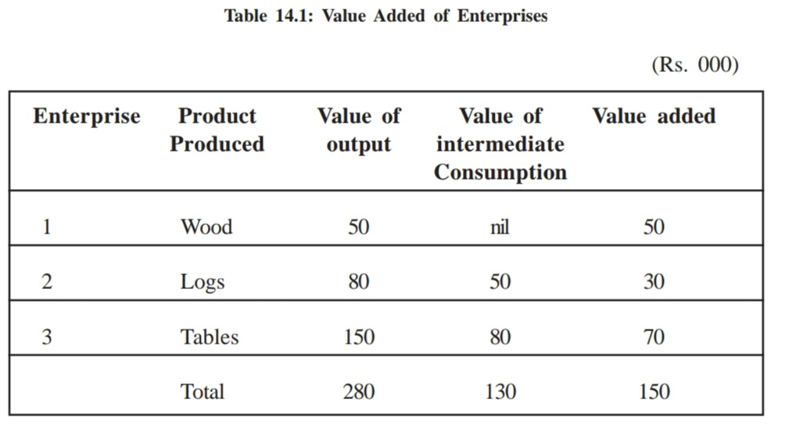
It is clear from Table 14.1 that value of wood produced (or trees cut) is Rs. 50,
000 and the same wood when converted into logs by the second enterprise is worth
Rs. 80, 000. These logs further processed by the third enterprise into tables which
worth Rs. 150, 000. The total value of output by all the three enterprises is equal
to Rs. 2, 80,000 (i.e., Rs. 50, 000 + Rs. 80, 000 + Rs. 150, 000). This cannot be
called gross domestic product of an economy because of counting, since wood is
included in logs and logs in tables. There are two ways of avoiding double counting:
(a) Take only the final products and do not consider the production of enterprises,
which produce raw materials or semi-finished products. But this method is difficult
to apply since it is not easy to decide between a raw material and a finished
product. For example, wood, if used to make logs, is a raw material but would be
a finished product, if used as a fuel by household. Therefore, this method is not
employed for estimating GDP of an economy. In the example given above, the
value of production of the third enterprise, i.e., Rs. 1, 50,000 is GDP of an economy;
(b) the other way of avoiding double counting is to consider value added by each
producing unit. Value added makes the output of a producing unit free of the value
of intermediate consumption.
Value added by each of the three producing units in Table 14.1 is Rs. 50, 000, Rs.
30, 000 and Rs. 70, 000 respectively, which add up to Rs. 1, 50,000. This is the
GDP of the economy estimated by first and second methods. It may be worthwhile
to note that the second method is easier to apply than that of the first.

It is also important to note that :
i) sum of gross value added at market price of all producing units gives us gross domestic product at market price;
ii) sum of gross value added at factor cost of all producing units gives us gross
domestic product at factor cost;
iii) net domestic product at factor cost is estimated by adding net value added at
factor cost of all the producing units of an economy; and finally,
iv) net domestic product at market price is computed by summing up net value
added at market price of all the producing units of an economy.
Net Factor Income from Abroad
The concept of net factor income from abroad has to be added to net domestic
product at factor cost for getting the national income. It consists of
1) net compensation of employees,
2) net income from property and entrepreneurship, and
3) net retained earnings of resident companies abroad.
Net Compensation of Employees from Abroad
Net compensation of employees receivable from abroad is equal to the difference
between compensation of employees received by resident employees who are
living or employed abroad temporarily and compensation of foreign nationals working temporarily in the domestic economy. The clause temporary resident applies to those employees who stay abroad for less than one year. In case they stay for one year or more in a foreign country they would be treated as normal residents of that country and their income would be a part of the national income of the employer country. In such a situation, whatever remittances they send to their country would be treated as current transfers from abroad and will not form a part of the national income. Net compensation of employees, as it is defined, can be a positive or a negative value.
Net Income from Property and Entrepreneurship from Abroad
Net income from property and Entrepreneurship from abroad is the difference
between the income received by way of interest, rent, dividend and profit by the
resident producers of a country and payments of similar type made to the rest of
the world. This also includes net interest received by the government on foreign
loans.
Net Retained Earnings of Resident Companies Abroad
Retained earning refers to the undistributed profit of the companies. Resident
companies abroad (i.e., companies belonging to one country and working in the
domestic territory of some other country) retain a part of their profits for further
investment abroad. Likewise, foreign companies and their branches retain a part of
their profits in the countries of their operation. The difference between retained
earning of the foreign companies located in a country and retained earning of
resident companies located abroad is equal to net retained earnings from abroad.
Thus, net factor income from abroad is equal to net compensation of employees
from abroad plus net property and entrepreneurship income from abroad plus net
retained earning of resident companies abroad.
Let us state the definition of net factor income from abroad, given in a formal way,
by Central Statistical Organization (CSO) of India. It is stated as, “Income attributable to factor services rendered by the normal residents of the country to the rest of the world less factor services rendered to them by the rest of the world. It also includes retained earnings of foreign-controlled rupee companies and branches of foreign companies in the domestic territory. Residents include both individuals and institutions. Tourists or commercial travelers of a given country traveling abroad are treated as residents of their home countries. The official diplomatic and consular representatives of a given country including members of official missions and members of the armed forces stationed abroad are to be considered extra territorial by the country in which they are located and as residents of the given country. The factor incomes generated by such residents are domestic product of the resident country. Factor incomes of locally recruited staff of foreign diplomatic military establishments are included in factor incomes from abroad.” (try to understand what all is included in net factor income from abroad)

The concept of net factor income from abroad is employed to arrive at gross
national product at market price, gross national product at factor cost, net national
product at market price and net national product at factor cost (national income)
of an economy. Thus, we have the following concepts:

a) Gross domestic product at market price + net factor income from abroad = gross
national product at market price. (GDP_{MP} )…Try to write the abbreviated terms for the following as explained in the video uploaded for you on National Income.
b) Gross domestic product at factor cost + net factor income from abroad = gross
national product at factor cost.
c) Net domestic product at market price + net factor income from abroad = net
national product at market price.
d) Net domestic product at factor cost + net factor income from abroad = net national product at factor cost (national income)
Normally, domestic product (gross or net, at market price or factor cost) is first computed and adjustments are made by including net factor income from abroad to arrive at national product (gross or net at market price or factor cost).

In estimating national income of an economy by the production method, the following points should be kept in mind. (Very Important)

1) Production for self-consumption has to be included in national income. In order to find out the value of production for self-consumption, the physical production has to be multiplied by market price to get imputed value of production for consumption.
2) Imputed rent in case of owner-occupied houses has to be included in national
income. Imputation of rent has to be done such that it will be equal to the services rendered by owner-occupied dwellings.
3) Own-account production by the government, private enterprises and households
has to be found out and added to other items for calculating national income
of an economy.
4) Sale and purchase of second-hand goods by sectors do not constitute a part of
current production and, therefore, are not included in national income in the year in which their sale or purchase takes place. But if sale and purchase of second hand goods take place through a broker, then the services rendered by these brokers are a part of national income of an economy. The services rendered by these brokers are expressed as equal to the commission and brokerage earned by them.

2. Income Method
Net value added at factor cost of a producing unit is identical to the sum of factor
incomes - compensation of employees and operating surplus or mixed income of the self-employed entrepreneurs. So, we can sum up compensation of employees and operating surplus or mixed income of the self-employed to estimate national increase.
If factor incomes generated by all the producing units within the domestic territory
of an economy are added up, net domestic product at factor cost is arrived at.
Further, if net factor income from abroad is added to net domestic product at factor
cost of an economy, net national product at factor cost or national income of an
economy can be estimated.
Given net national product at factor cost if the depreciation provision is added to
it, gross national product at factor cost is arrived at. If net indirect taxes are added
to gross national product at factor cost, gross national product at market price can
be calculated.
The main steps involved in estimating national income by the income method are:
1) to identify the producing enterprises, which use services of the factors of production
2) to classify various types of factor payments
3) to estimate various components of factor payments
4) to estimate net factor income from abroad, which has to be added to net
domestic product at factor cost to arrive at net national product at factor cost
or national income of an economy.
The classification of producing units that is adopted by the production method of estimating national income can be used for the income method also.
The factor payments are generally classified into the following categories:
a) Compensation of employees
b) Rent
c) Interest
d) Profits
e) Mixed income of the self-employed
Moreover, factor payments can be classified into: (a) compensation of employees,
(b) operating surplus, (c) mixed income of the self-employed. There are a few
points to be kept in mind while estimating national income by income method.

1) A distinction has to be made between factor and income transfer income. While
factor incomes are earned by factors of production, transfer incomes are enjoyed
by various economic agents without supplying factor services. It is only factor
incomes that constitute national income. Accordingly, transfer incomes are excluded from national income of an economy.
2) The services of owner-occupied dwellings are equal to imputed rent of the
dwelling. Imputed rent adjusted for maintenance expenditure of dwellings is
included in national income by production method.
3) Income earned by the act of smuggling or gambling as well as windfall gains
like lotteries are not included in the estimation of national income.
4) National Income of an economy includes direct taxes like income tax and
corporate tax. It may be useful to remember that compensation of employees
includes income tax to be paid by them and are included in national income
before deduction of corporate tax. Death duties, gift tax, wealth tax, etc., are
supposed to be paid from the wealth or past savings of those persons who pay
these taxes and not out of current income. Therefore, such taxes are not
included in the estimation of national income.
5) Sale and purchase of second-hand goods are not included in national income of
an economy. The sale proceeds of second-hand goods received by a person do
not relate to any service rendered and, therefore, do not constitute a part of
national income.

3. Expenditure Method
Income generated in the process of production is received by factors of production.
Such income can be divided into two parts viz., (a) income from work and (b)
income from ownership of capital and entrepreneurship. Incomes from work are
enjoyed by the workers while those of ownership of entrepreneurship are enjoyed
by their owners. The income earned by factors of production is either saving.
Savings generated, in turn, are used for adding to the capital stock or what is called
investment. If the final consumption and gross investment expenditure of all economic agents including the rest of the world are added up, this gives us the gross domestic product at market price for an economy. From the GDP at market price, we deduct depreciation provision and net indirect taxes to get net domestic product at factor cost. Add net factor income from abroad to net domestic product at factor cost to get net national product at factor cost (or national income) of an economy. Various components of final expenditures constituting gross domestic product at market price are:
1) private final consumption expenditure,
2) government’s final consumption expenditure,
3) gross domestic fixed capital formation,
4) change in stock, and
5) net export of goods and services.
We require two types of statistical data for the estimation of final private expenditure:
(a) total volume of sales in the market, and (b) retail prices at which goods and
services are purchased by the households. The volume of final sales is to be
multiplied by the retail prices of goods and services.
Production for self-consumption is a part of production and hence an income and
is also a part of final consumption expenditure. Accordingly, the volume of production for self-consumption has to be multiplied with the prices existing in the markets near the producing unit. Similarly, the imputed rent of owner-occupied dwellings is included in production and income and also in private final consumption expenditure in the domestic market.
Government Final Consumption Expenditure
The value of government final consumption expenditure is equal to the value of the
services produced (such as public health, cultural services, defence, and law and
order) by the government for collective use by the public. These services are
valued at their cost to the government, since they are not normally sold to its
citizens. The cost of these services is the sum of value of: (a) intermediate
consumption, (b) compensation of employees (wages, salaries in cash and in kind),
(c) the direct purchases of goods and services made by the government abroad for
their embassies and consulates located abroad and, (d) less sale of goods and
services produced by the general government. Examples of sales by general
government are nominal money charged by government hospitals from individuals
availing themselves of the hospital facilities or government publications sold by the government to the general public.
Gross Domestic Fixed Capital Formation
Gross fixed capital formation consists of the outlays of industries, producers of
government services and producers of private non-profit services to households, on
addition of new durable goods to the stocks of fixed assets less net sales of similar
second-hand and scrapped goods.
Change in Stocks
Stocks consists largely of materials and supplies, work-in-progress (except in
construction projects) and finished products in the possession of industries.

Net Export of Goods and Services
Net export of goods and services is the difference between value of export and
import of goods and services over a year. Accordingly, net export can be positive
or negative, positive when exports are more than imports, and negative when reverse is the case.
There are a few points to be kept in mind while estimating national income by the expenditure method.
1) Expenditure on all intermediate goods and services is to be excluded. This is done primarily to avoid double counting. A good or service is said to be intermediate if a producing unit sells it to another producing unit for resale or for further processing.
2) All government expenditure on transfer payments is excluded from national
income. Some examples of such transfer payments are unemployment benefits,
old age pensions and scholarships given to students for education purposes.
Those who receive these transfers are not expected to render any service in exchange.
3) All expenditures on second-hand goods are excluded since they are not from
the currently produced goods and services. Similarly, expenditure on the purchase
of old shares or bonds or debentures from other people or new shares, bonds or debentures from producing units or government are excluded since they are not payments for a good or service currently produced. There is only transfer of property from one person to another.

**********

