LINEAR PROGRAMMING – NOTE-3

Example 1: Solve the following problem graphically:
Minimise and Maximise Z = 3x + 9y ... (1)
subject to the constraints: x + 3y ≤ 60 ... (2)
x + y ≥ 10 ... (3)
x ≤ y ... (4)
x ≥ 0, y ≥ 0 ... (5)
Solution: First of all, let us graph the feasible region of the system of linear inequalities
(2) to (5). The feasible region ABCD is shown in the Fig 12.4. Note that the region is
bounded. The coordinates of the corner points A, B, C and D are (0, 10), (5, 5), (15,15)
and (0, 20) respectively.
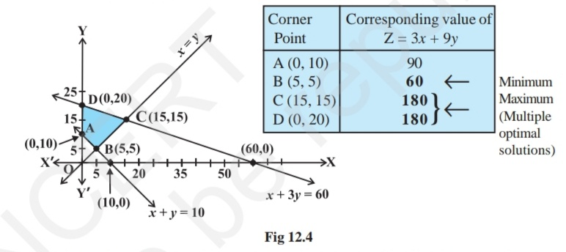
We now find the minimum and maximum value of Z. From the table, we find that
the minimum value of Z is 60 at the point B (5, 5) of the feasible region. The maximum value of Z on the feasible region occurs at the two corner points C (15, 15) and D (0, 20) and it is 180 in each case.

NOTE: Observe that in the above example, the problem has multiple optimal solutions at the corner points C and D, i.e. the both points produce same maximum value 180. In such cases, you can see that every point on the line segment CD joining the two corner points C and D also give the same maximum value. Same is also true in the case if the two points produce same minimum value.

Example 2: Determine graphically the minimum value of the objective function
Z = – 50x + 20y ... (1)
subject to the constraints:
2x – y ≥ – 5 ... (2)
3x + y ≥ 3 ... (3)
2x – 3y ≤ 12 ... (4)
x ≥ 0, y ≥ 0 ... (5)

Solution: First of all, let us graph the feasible region of the system of inequalities (2) to
(5). The feasible region (shaded) is shown in the Fig 12.5 below. Observe that the feasible
region is unbounded.
We now evaluate Z at the corner points.

From this table, we find that – 300 is the smallest value of Z at the corner point
(6, 0). Can we say that minimum value of Z is – 300? Note that if the region would
have been bounded, this smallest value of Z is the minimum value of Z (Theorem 2).
But here we see that the feasible region is unbounded. Therefore, – 300 may or may
not be the minimum value of Z. To decide this issue, we graph the inequality
– 50x + 20y < – 300 (see Step 3(ii) of corner Point Method.)
i.e., – 5x + 2y < – 30
and check whether the resulting open half plane has points in common with feasible region or not. If it has common points, then –300 will not be the minimum value of Z. Otherwise, –300 will be the minimum value of Z.

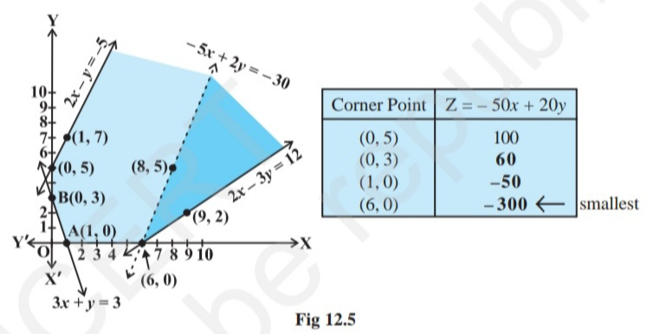

As shown in the Fig 12.5, it has common points. Therefore, Z = –50 x + 20 y has no minimum value subject to the given constraints.

Example 3: Minimise Z = 3x + 2y
subject to the constraints:
x + y ≥ 8 ... (1)
3x + 5y ≤ 15 ... (2)
x ≥ 0, y ≥ 0 ... (3)

Solution: Let us graph the inequalities (1) to (3) (Fig 12.6). Is there any feasible region?
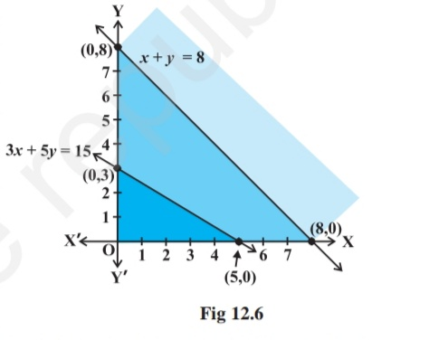
Why is so?
From Fig 12.6, you can see that there is no point satisfying all the constraints simultaneously. Thus, the
problem is having no feasible region and hence no feasible solution.

Note: From the examples which we have discussed so far, we notice some general features of linear programming problems:
(i) The feasible region is always a convex region.
(ii) The maximum (or minimum) solution of the objective function occurs at the vertex (corner) of the feasible region. If two corner points produce the same maximum (or minimum) value of the objective function, then every point on the line segment joining these points will also give the same maximum (or minimum) value.

*******

